Full Stack Engineer (React + TypeScript + Backend)
Timebox: 3–4 hours
Difficulty: Real-world product problem
AI Usage: Allowed (see below)

Provided Data
You are given 5 JSON files representing 1 year of sales data:
- accounts.json – customer accounts
- reps.json – sales representatives
- deals.json – sales deals
- activities.json – calls/emails
- targets.json – monthly revenue targets
Assume this data comes from multiple real systems and may contain inconsistencies

Your Task
Build a single-page Revenue Intelligence Console.
It should help a CRO answer:
“Why are we behind (or ahead) on revenue this quarter,
and what should we focus on right now?”

Functional Requirements

Backend (TypeScript)

1. Summary - /api/summary
- Current Quarter Revenue
- Target
- Gap (%)
- YoY or QoQ change

2. Revenue Drivers - /api/drivers
Explain performance using:
- Pipeline size
- Win rate
- Average deal size
- Sales cycle time

3. Risk Factors - /api/risk-factors
Identify:
- Stale deals
- Underperforming reps
- Low activity accounts

4. Recommendations - /api/recommendations
Return 3–5 actionable suggestions, e.g:
- “Focus on Enterprise deals older than 30 days”
- “Coach Rep A on win rate”
- “Increase activity for Segment B”

Frontend (React + TypeScript)
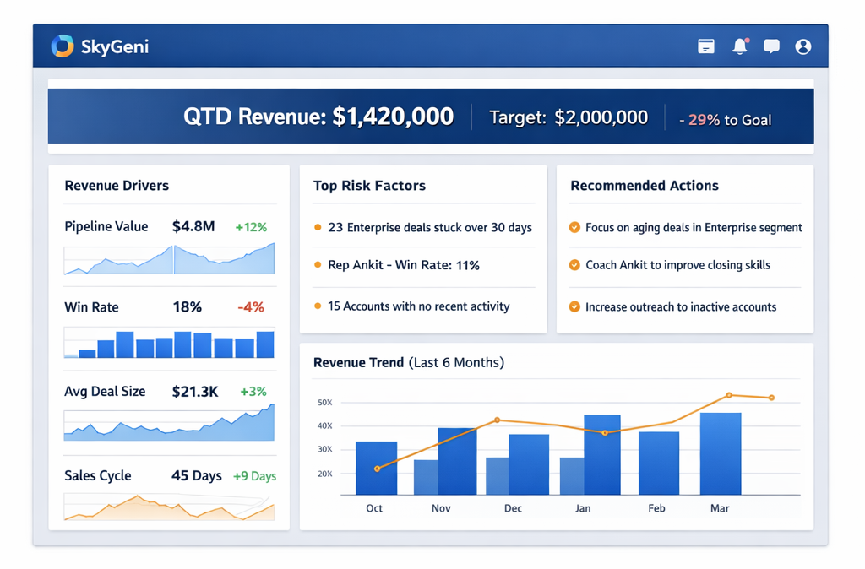

Constraints
- You may use any SQL database (SQLite / Postgres / MySQL / in-memory)
- You need to use Material UI and D3 charting only
- You may use AI tools (ChatGPT, Copilot, Cursor)

Critical Deliverable – Reflection
Create a file:
THINKING.md
Answer:
- What assumptions did you make?
- What data issues did you find?
- What tradeoffs did you choose?
- What would break at 10× scale?
- What did AI help with vs what you decided?
This document is as important as your code.

Submission
Share a GitHub repo with:
/backend
/frontend
/data
THINKING.md
README.md

Also, API endpoints should be same as specified above.

